

Python 00P Project Documentation

Project Title: Student Information Management System
Project Summary:we took a decision about making student information project on Python OOP project as we had a subject of database on 4th semester, we have made a project combined of database and Python OOP.with this we can add,update, delete and search a data of a student.

Development Platform:
Operating System : Linux
IDE : Pycharm
Module : Tkinter(GUI),sqlite3(Database)

Developers:

Name : MEHEDI MD ASIF
ID Number : 2017002115
Passport Number : BK0100608
Nationality : Bangladesh

Name : SHAWON MD JAHUNGIR HOSSAIN
ID Number : 2017002103
Passport Number : BM0951231
Nationality : Bangladesh

Name : ROY DIPTO
ID Number : 2017002117
Passport Number : BF0022562
Nationality : Bangladesh

Table Of Contents

1.0 Design..............................................3 1.1 Problem definition................................3 1.2 Solution specification ...........................3
1.3 Project UI Design.................................3

2.0 Develop.............................................4 2.1 Implementation ...................................4 2.2 Testing for errors................................4

3.0 Code................................................5
3.1 Implementation code.......................5,6,7,8,9
3.2 Input.............................................9
3.3 Output...........................................10

4.0 Evaluate...........................................10

5.0 Source Code Link...................................10

1.0 Design: on design we have used GUI.in Python we have used a popular GUI module "tkinter". We have used button for add,delete, update and search;for input we used Entry ;for output we used School bar Attribute.

1.1 Problem definition:we need some basic data of a student as:name, passport, country, department etc,these we will collect from user as input and save India n database as data.so that we can update, delete and search those user information.

1.2 Solution specification : for design by using tkinter module firstly we take name,nationality,passport number, department and for input we use Entry attribute and then fix it’s site.then to save these inputs as:add,search, update, delete in database we set viewall button.

1.3 Project UI Design :

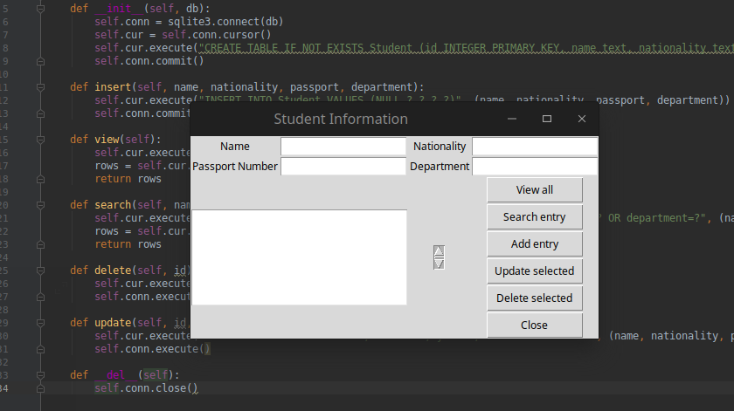

2.0 Develop :Develop have two part one is implementation and other is Error.

2.1 Implementation : firstly we import Sqlite 3 module in a file named StudentDB in Python file.then we made Database class.then we connect Sqlite3 in Database class;create Database table.then we declare some insert,view,search, delete,update of Sqlite3.by insert function data is saved,by view function data is being showed,by search function data is being searched, by delete function data is being deleted, by update function data is being updated and at last by DEL Database is being closed. Then we create a Python file named Student Panel.from student database we initialize the object of database class.then we create window class and initialize entry, button, scrollbar.then view-command,search-command,add-command,delete-command, update-command;by using these we connect all the functions from database and show the data.

2.2 Testing for errors: We face so many error because it’s difficult likes syntax error,type error,logical error etc but we fixed all the error.

3.0 Code :
3.1 Implementation code :
Student Panel.py

from tkinter import *
from StudentDB import Database

StudentDB = Database("Student.db")

class Window(object):

def __init__(self, window):
self.window = window
self.window.wm_title("Student Information")

l1 = Label(window, text="Name")
l1.grid(row=0, column=0)

l2 = Label(window, text="Nationality")
l2.grid(row=0, column=2)

l3 = Label(window, text="Passport Number")
l3.grid(row=1, column=0)

l4 = Label(window, text="Department")
l4.grid(row=1, column=2)

self.name_text = StringVar()
self.e1 = Entry(window, textvariable=self.name_text)
self.e1.grid(row=0, column=1)

self.nationality_text = StringVar()
self.e2 = Entry(window, textvariable=self.nationality_text)
self.e2.grid(row=0, column=3)

self.passport_text = StringVar()
self.e3 = Entry(window, textvariable=self.passport_text)
self.e3.grid(row=1, column=1)

self.department_text = StringVar()
self.e4 = Entry(window, textvariable=self.department_text)
self.e4.grid(row=1, column=3)

self.list1 = Listbox(window, height=6,width=35)
self.list1.grid(row=2, column=0, rowspan=6, columnspan=2)

sb1 = Scrollbar(window)
sb1.grid(row=2, column=2, rowspan=6)

self.list1.configure(yscrollcommand=sb1.set)
sb1.configure(command=self.list1.yview)

self.list1.bind('<<ListboxSelect>>', self.get_selected_row)

b1 = Button(window, text="View all", width=12, command=self.view_command)
b1.grid(row=2, column=3)

b2 = Button(window, text="Search entry", width=12, command=self.search_command)
b2.grid(row=3, column=3)

b3 = Button(window, text="Add entry", width=12, command=self.add_command)
b3.grid(row=4, column=3)

b4 = Button(window, text="Update selected", width=12, command=self.update_command)
b4.grid(row=5, column=3)

b5 = Button(window, text="Delete selected", width=12, command=self.delete_command)
b5.grid(row=6, column=3)

b6 = Button(window, text="Close", width=12, command=window.destroy)
b6.grid(row=7, column=3)

def get_selected_row(self, event):
index = self.list1.curselection()[0]
self.selected_tuple = self.list1.get(index)
self.e1.delete(0, END)
self.e1.insert(END, self.selected_tuple[1])
self.e2.delete(0, END)
self.e2.insert(END, self.selected_tuple[2])
self.e3.delete(0, END)
self.e3.insert(END, self.selected_tuple[3])
self.e4.delete(0, END)
self.e4.insert(END, self.selected_tuple[4])

def view_command(self):
self.list1.delete(0, END)
for row in StudentDB.view():
self.list1.insert(END, row)

def search_command(self):
self.list1.delete(0, END)
for row in StudentDB.search(self.name_text.get(), self.nationality_text.get(), self.passport_text.get(), self.department_text.get()):
self.list1.insert(END, row)

def add_command(self):
StudentDB.insert(self.name_text.get(), self.nationality_text.get(), self.passport_text.get(), self.department_text.get())
self.list1.delete(0, END)
self.list1.insert(END, (self.name_text.get(), self.nationality_text.get(), self.passport_text.get(), self.department_text.get()))

def delete_command(self):
StudentDB.delete(self.selected_tuple[0])

def update_command(self):
StudentDB.update(self.selected_tuple[0], self.name_text.get(), self.nationality_text.get(), self.passport_text.get(), self.department_text.get())

window=Tk()
Window(window)
window.mainloop()

StudentDB.py

import sqlite3

class Database:
def __init__(self, db):
self.conn = sqlite3.connect(db)
self.cur = self.conn.cursor()
self.cur.execute("CREATE TABLE IF NOT EXISTS Student (id INTEGER PRIMARY KEY, name text, nationality text, passport integer, department integer)")
self.conn.commit()

def insert(self, name, nationality, passport, department):
self.cur.execute("INSERT INTO Student VALUES (NULL,?,?,?,?)", (name, nationality, passport, department))
self.conn.commit()

def view(self):
self.cur.execute("SELECT * FROM Student")
rows = self.cur.fetchall()
return rows

def search(self, name="", nationality="", passport="", department=""):
self.cur.execute("SELECT * FROM Student WHERE name=? OR nationality=? OR passport=? OR department=?", (name, nationality, passport, department))
rows = self.cur.fetchall()
return rows

def delete(self, id):
self.cur.execute("DELETE FROM Student WHERE id=?", (id,))
self.conn.execute()

def update(self, id, name, nationality, passport, department):
self.cur.execute("UPDATE Student SET title=?, author=?, year=?, isbn=? WHERE id=?", (name, nationality, passport, department))
self.conn.execute()

def __del__(self):
self.conn.close()

3.2 Input :

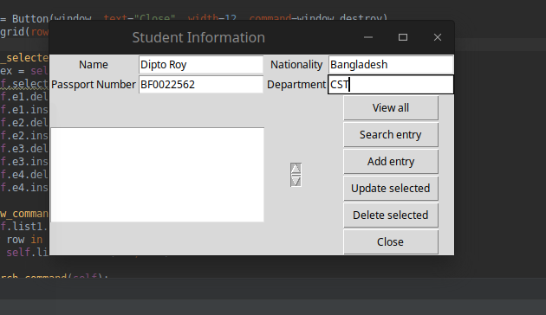

3.3 Output :

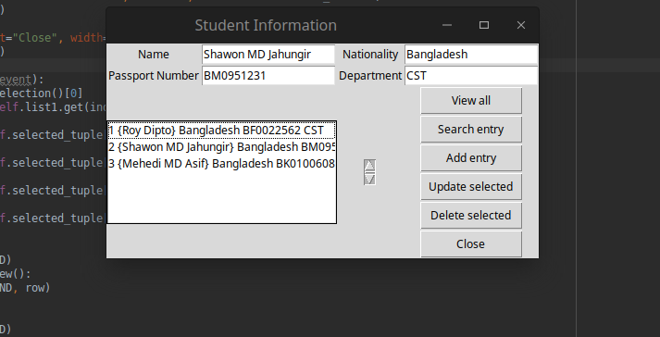

4.0 Evaluate : We have completed the project very well.Through the project we learn Python OOP as well as it’s various module, database and make a great project by using it together. Through this we have learned to used class, object, function and more. We are happy to do this project.

5.0 Source Code Link : We put our project source code in Github .Check please https://github.com/diptoroy/Student_Information

